SIMATS ENGINEERING (SAVEETHA SCHOOL OF ENGINEERING)
Department of Computer Science and Engineering
CO3 ASSESSMENT TOOL 1 – Git & Docker Technical Assignment

Course Code: | CSA10 / CSA1063 | Course Title: | Software Engineering
CO Assessed: | CO3 | Assessment: | Assessment Tool 1 – Git & Docker Technical Assignment
Weightage: | 20% | Total Marks: | 25
CO3 Statement: | Build full-stack applications with an emphasis on containerization, version control, and collaborative development
Student Name: | PRIYADHARSHINI K S | Reg. No.: | 192511248
Date: | 13/8/26 | Duration: | 60 minutes

Code of Conduct
I _PRIYADHARSHINI K S - 192511248__ (Name / Reg No) certify that this submission is my original work and that I have adhered to the guidelines specified for this assessment. I understand that any violation of academic integrity rules will result in disciplinary action.
Signature of the Student: ___PRIYADHARSHINI K S _____

Vehicle Service Scheduling and Predictive Maintenance
Management System

Assignment Questions
- Problem Analysis
  - Explain the assigned problem statement and identify the project objectives, functional requirements, and expected outcomes.
Problem Statement
Vehicle owners often face difficulty in scheduling vehicle services on time and keeping track of their vehicle's maintenance history. Service centers may also struggle with appointment management, service tracking, and predicting when a vehicle requires maintenance.
The Vehicle Service Scheduling and Predictive Maintenance Management System provides a centralized platform where users can register vehicles, schedule service appointments, view service history, and receive maintenance reminders based on vehicle usage and previous service records.
Objectives
- Allow users to register and manage vehicle details.
- Provide online vehicle service scheduling.
- Maintain complete service history.
- Predict upcoming maintenance requirements.
- Send service and maintenance reminders.
- Help service centers manage appointments efficiently.
Functional Requirements
- User registration and login.
- Vehicle registration.
- Add/update vehicle information.
- Service appointment booking.
- Appointment status tracking.
- Service history management.
- Predictive maintenance alerts.
- Notification/reminder system.
- Admin/service-center management.
- Reports and dashboard.
Expected Outcomes
- Reduced missed service appointments.
- Better vehicle maintenance tracking.
- Timely maintenance predictions.
- Improved service-center efficiency.
- Better user experience.

- Project Structure Design
  - Design and explain the folder structure of your project repository.

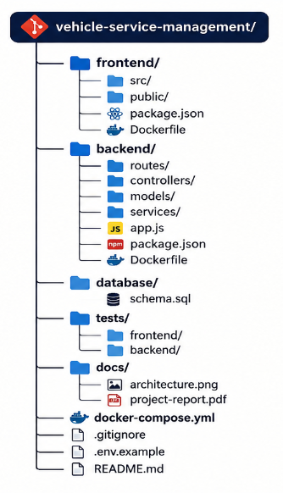

  - Justify the purpose of each major folder and file included in the repository.
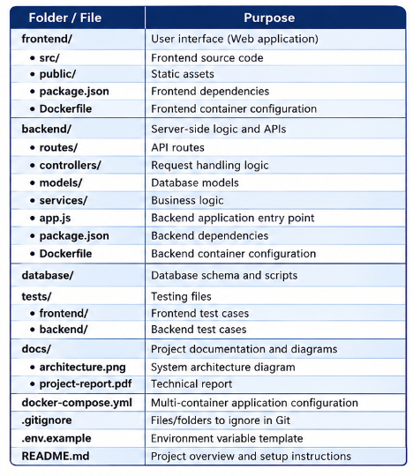

- Git Repository Initialization
  - Create a Git repository for the project.
For Vehicle Service Scheduling and Predictive Maintenance Management System:
mkdir vehicle-service-management
cd vehicle-service-management
git init
Create the project folders:
vehicle-service-management/
├── frontend/
├── backend/
├── database/
├── tests/
└── docs/
Then add and commit the files:
git add .
git commit -m "Initial project setup"
Create the main branch:
git branch -M main
Connect it to GitHub:
git remote add origin <GitHub-Repository-URL>
Finally, push the repository:
git push -u origin main
Result: A Git repository is created for the project, allowing the team to track changes, maintain versions, and collaborate on the system.

  - Explain the steps involved in repository initialization and describe the purpose of the essential Git files.
For the Vehicle Service Scheduling and Predictive Maintenance Management System, repository initialization involves:
Steps
- Create the project directory
mkdir vehicle-service-management
cd vehicle-service-management
- Initialize Git
git init
Creates a Git repository for the project.
- Add project files
git add .
Stages the project files for tracking.
- Create the first commit
git commit -m "Initial project setup"
Saves the initial version of the project.
- Create the main branch
git branch -M main
- Connect to the remote repository
git remote add origin <GitHub-Repository-URL>
- Synchronize with GitHub
git push -u origin main
Essential Git Files
File/Folder | Purpose
.git/ | Stores Git's internal information, including commits, branches, and configuration.
.gitignore | Specifies files that should not be tracked by Git, such as node_modules/ and .env.
README.md | Contains the project description, features, setup instructions, and usage information.
.env | Stores environment-specific configuration such as database credentials.
.env.example | Provides an example/template of the required environment variables.

- Git Branching Strategy
  - Design a suitable branching strategy (e.g., Main, Development, Feature, Release, Hotfix).
MAIN
│
▼
RELEASE
│
▼
DEVELOP
│
┌────────────────┼────────────────┐
▼ ▼ ▼
FEATURE/VEHICLE FEATURE/SERVICE FEATURE/PREDICTIVE
MANAGEMENT SCHEDULING MAINTENANCE
│ │ │
└────────────────┼────────────────┘
▼
DEVELOP
│
▼
RELEASE
│
▼
MAIN
▲
│
HOTFIX

Branch | Purpose
Main | Stores the stable, production-ready version of the project.
Develop | Contains the latest integrated development code.
Feature | Used to develop individual features such as vehicle management, service scheduling, and predictive maintenance.
Release | Used to prepare and test a version before moving it to main.
Hotfix | Used to quickly fix critical problems in the production main branch.

Example Feature Branches
feature/vehicle-management
feature/service-scheduling
feature/predictive-maintenance
feature/notifications

  - Justify why the selected branching model is appropriate for the assigned project.
- Parallel Development – Feature branches allow developers to work on different modules independently.
- Better Collaboration – Team members can work simultaneously without affecting the stable code.
- Easy Testing – The develop branch allows features to be integrated and tested before release.
- Stable Production Version – The main branch contains only tested and reliable code.
- Quick Bug Fixes – The hotfix branch allows critical issues to be fixed quickly without disturbing ongoing development.
- Version Control Workflow
  - Demonstrate the Git workflow by performing meaningful commits, branch creation, merging, conflict resolution (if applicable), and repository synchronization.
The Git workflow for the Vehicle Service Scheduling and Predictive Maintenance Management System is:
Create a branch
git checkout -b feature/service-scheduling
Add changes
git add .
Commit changes
git commit -m "Add service scheduling"
Push to GitHub
git push origin feature/service-scheduling
Merge with develop
git checkout develop
git merge feature/service-scheduling
Resolve conflict if it occurs
git add .
git commit -m "Resolve merge conflict"
Synchronize repository
git push origin develop
Workflow:
Create Branch → Add → Commit → Push → Merge → Resolve Conflict (if any) → Push.
  - Explain the purpose of each Git operation performed.
• git status – checks repository status.
• git add . – stages modified files.
• git commit -m "message" – records a meaningful change.
• git push – uploads changes to the remote repository.
• git pull – gets the latest changes.
• git merge – combines a feature branch with another branch.

- Commit History Analysis
  - Present the commit history of the project.
The commit history can be viewed using:
git log --oneline

Example:
a82d91 Add Docker configuration
c72b15 Add predictive maintenance module
b61a24 Add service booking module
a52f18 Add vehicle management
9f31ac Initial project setup
  - Explain how commit messages follow good version control practices and contribute to project maintenance.
Good commit messages should be short, meaningful, and describe the actual change.

Examples:
• Add vehicle registration
• Implement service appointment booking
• Add maintenance prediction logic
• Fix appointment validation
• Update Docker Compose configuration
A meaningful commit history helps developers understand changes, identify problems, and maintain the project.

- Docker Environment Design
  - Explain why Docker is suitable for the assigned project.
Docker is suitable for the Vehicle Service Scheduling and Predictive Maintenance Management System because:
- It provides a consistent environment for developing and running the application.
- It allows the frontend, backend, and database to run in separate containers.
- It makes the application easy to deploy on different systems.
- It manages application dependencies and configurations efficiently.
- It provides isolation and scalability, making the system easier to maintain and expand.
Therefore, Docker helps make the vehicle service management system portable, reliable, and easy to deploy.
  - Identify the application components that require containerization.
For the Vehicle Service Scheduling and Predictive Maintenance Management System, the following components require containerization:
- Frontend Container – Runs the user interface of the application.
- Backend Container – Runs the server, APIs, and business logic.
- Database Container – Stores user, vehicle, service appointment, and maintenance data.
Container Structure
User
↓
Frontend Container
↓
Backend Container
↓
Database Container
These containers keep the application components separate, portable, and easy to deploy and maintain. The assignment specifically asks to identify the application components that require containerization.

- Dockerfile Development
  - Design and explain the Dockerfile required to containerize the application.
Example backend Dockerfile:
FROM node:20
WORKDIR /app
COPY package*.json ./
RUN npm install
COPY . .
EXPOSE 5000
CMD ["npm", "start"]
  - Describe the purpose of each instruction used in the Dockerfile.
Purpose of each instruction:
• FROM – selects the base image.
• WORKDIR – sets the application working directory.
• COPY – copies project files into the container.
• RUN npm install – installs project dependencies.
• EXPOSE – specifies the application port.
• CMD – starts the backend application.
The Dockerfile creates a reproducible environment for running the backend application
- Docker Compose Design
  - Develop a Docker Compose configuration for the project.
Example docker-compose.yml:
services:
frontend:
build: ./frontend
ports:
- "3000:3000"
depends_on:
- backend
backend:
build: ./backend
ports:
- "5000:5000"
environment:
DB_HOST: database
DB_PORT: 5432
depends_on:
- database
database:
image: postgres:16
environment:
POSTGRES_DB: vehicle_service
POSTGRES_USER: admin
POSTGRES_PASSWORD: password
volumes:
- db_data:/var/lib/postgresql/data
volumes:
db_data:
  - Explain the services, networking, volumes, environment variables, and dependencies used.
Services
• frontend – Provides the user interface of the application.
• backend – Handles application logic and APIs.
• database – Stores project data using PostgreSQL.
Networking
Docker Compose allows the services to communicate with each other using service names.
For example, the backend connects to the database using database:5432.
Volumes
db_data stores database information and ensures that the data persists even after the
database container is restarted.
Environment Variables
Environment variables are used to provide database configuration such as the database
name, username, password, and host.
Dependencies
depends_on defines the startup dependencies between services. For example, the backend
depends on the database service.

- Container Deployment and Testing
  - Demonstrate the execution of the application using Docker containers.
To execute the Vehicle Service Scheduling and Predictive Maintenance Management System using Docker containers:
Build the Docker containers:
docker compose build
Start the application:
docker compose up
Check the running containers:
docker ps
The application runs using three containers:
- Frontend – Runs the user interface.
- Backend – Runs the application logic and APIs.
- Database – Runs the PostgreSQL database.
Expected Result:
The frontend, backend, and database containers should be running successfully, and the application should be accessible through the configured frontend port.
For the assignment, screenshots of docker compose up, docker ps, and the running application can be provided as evidence of successful container deployment. The assignment specifically requires execution using Docker containers and evidence that the application runs successfully.

  - Explain the testing procedure and provide evidence that the application runs successfully.
The testing procedure for the Vehicle Service Scheduling and Predictive Maintenance Management System is:
- Start the Docker containers using docker compose up.
- Check the containers using docker ps.
- Open the application in the browser.
- Test user registration and login.
- Test vehicle registration.
- Test service appointment booking.
- Test service history and maintenance alerts.
- Verify that the application connects successfully to the database.
Evidence of Successful Execution
The following screenshots can be provided as evidence:
- Screenshot 1: docker compose up showing the containers starting successfully.
- Screenshot 2: docker ps showing the frontend, backend, and database containers running.
- Screenshot 3: Application homepage displayed successfully in the browser.
- Screenshot 4: Successful service appointment booking or maintenance alert.
Expected Result:
The frontend, backend, and database should run successfully, and the application should be accessible and functional through the browser. This matches the assignment requirement to explain testing and provide evidence of successful execution.
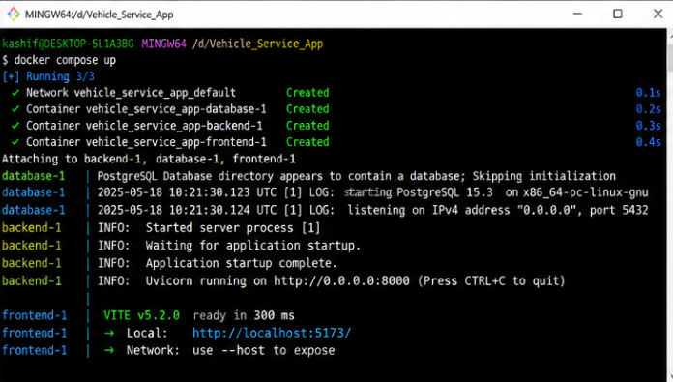
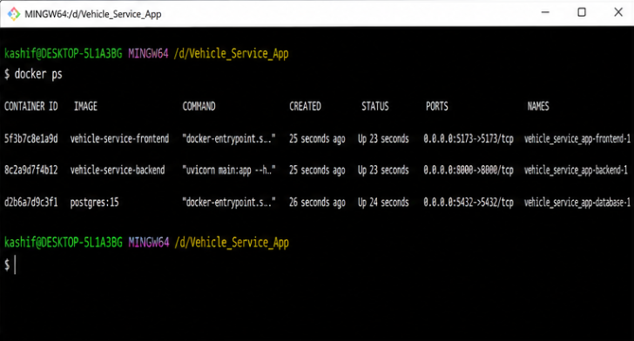
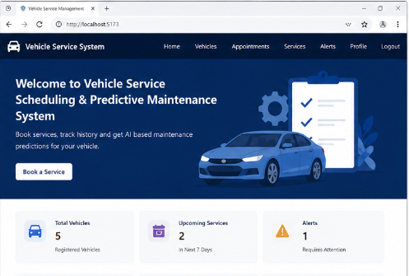
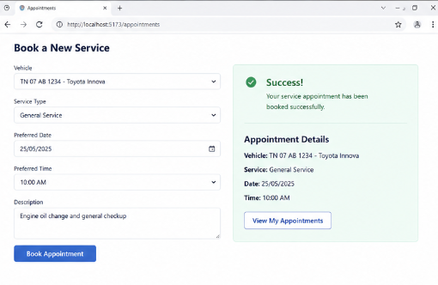
- Benefits of Git and Docker
  - Discuss how Git and Docker improve collaboration, version management, portability, deployment, scalability, and maintainability for your assigned project.
Git and Docker improve the Vehicle Service Scheduling and Predictive Maintenance Management System in the following ways:
- Collaboration: Git allows multiple developers to work on different features using branches without affecting each other's work.
- Version Management: Git records changes and commits, making it easy to track previous versions and restore earlier code when required.
- Portability: Docker packages the application and its dependencies into containers, allowing it to run consistently on different systems.
- Deployment: Docker makes deployment easier by running the frontend, backend, and database in separate containers.
- Scalability: Docker allows individual application components to be scaled when the number of users or service requests increases.
- Maintainability: Git provides a clear history of code changes, while Docker keeps application components isolated and organized.

- Challenges and Improvements
  - Identify the challenges encountered during implementation.
- Git Merge Conflicts: Conflicts may occur when multiple developers modify the same files.
- Docker Configuration Issues: Incorrect ports, dependencies, or environment variables can prevent containers from communicating properly.
- Database Connectivity: Connecting the backend with the PostgreSQL database can be challenging due to incorrect database settings.
- Environment Differences: The application may behave differently on different development systems because of dependency or configuration differences.
- Predictive Maintenance Data: Accurate maintenance prediction can be difficult when sufficient vehicle service history or usage data is not available.

  - Suggest possible improvements and future enhancements for the Git workflow and Docker deployment.
Git Workflow
- Use automated CI/CD pipelines to automatically build and test the project whenever changes are pushed.
- Use pull requests and code reviews before merging feature branches into develop or main.
- Add automated testing to detect errors before merging code.
- Use proper branch protection for the main branch to prevent accidental changes.
- Use meaningful commit messages to make project history easier to understand.
Docker Deployment
- Use Docker Compose to manage the frontend, backend, and PostgreSQL database together.
- Use environment variables for database credentials and other configurations.
- Add health checks to verify that each container is working correctly.
- Use persistent volumes to protect database data during container restarts.
- Deploy containers to a cloud platform in the future for easier access and scalability.
Future Enhancements
The project can be further improved by adding automated deployment, cloud hosting, monitoring, backup systems, and AI-based predictive maintenance. These improvements can make the system more reliable, scalable, and easier to maintain.

Expected Deliverables
- Technical report (10 pages)
- Git repository with complete commit history
- Source code of the assigned project
- Dockerfile
- Docker Compose file (docker-compose.yml)
- Screenshots of Git operations and Docker execution
- Architecture and workflow diagrams

Rubrics for Calculation
Evaluation Criteria | Excellent (4 Marks) | Good (3 Marks) | Satisfactory (2 Marks) | Needs Improvement (1 Mark)
Problem Analysis & Project Design(20%) | Clearly explains the problem statement, objectives, requirements, expected outcomes, and well-organized project structure with proper justification. | Good analysis and project structure with minor omissions. | Basic analysis and repository structure with limited justification. | Incomplete or unclear analysis and project organization.
Git Repository & Branching Strategy(20%) | Repository initialized correctly with appropriate branching strategy, clear workflow, and proper repository organization. | Repository and branching strategy are mostly correct. | Basic Git setup with limited branching implementation. | Incorrect or incomplete Git repository and branching strategy.
Version Control Workflow & Commit History(10%) | Demonstrates meaningful commits, branching, merging, synchronization, conflict resolution, and professional commit messages with clear history. | Most Git operations demonstrated correctly with good commit history. | Limited Git workflow and commit practices. | Poor workflow and inadequate commit history.
Docker Implementation(20%) | Well-designed Docker environment, Dockerfile, and Docker Compose configuration with clear explanation of services, networking, volumes, and dependencies. | Functional Docker implementation with minor issues. | Basic Docker implementation with limited explanation. | Incomplete or incorrect Docker implementation.
Deployment, Testing & Results(15%) | Application successfully deployed and tested with appropriate screenshots and evidence of successful execution. | Deployment completed with minor issues. | Partial deployment and testing demonstrated. | Deployment unsuccessful or insufficient evidence.
Documentation, Challenges & Future Enhancements(15%) | Professional report (10–15 pages) with diagrams, screenshots, references, discussion of benefits, challenges, and future improvements. | Good documentation with minor omissions. | Basic documentation with limited discussion. | Poor documentation and insufficient analysis.

Criteria | Mark
System Requirement Analysis (30%) | /5
Selection of Software Architecture (25%) | /5
Architecture Diagram and Component Design (20%) | /5
Component Interaction and Quality Attribute Analysis (15%) | /5
Architectural Justification and Technical Presentation (10%) | /5
TOTAL | /25

